**Q1.**

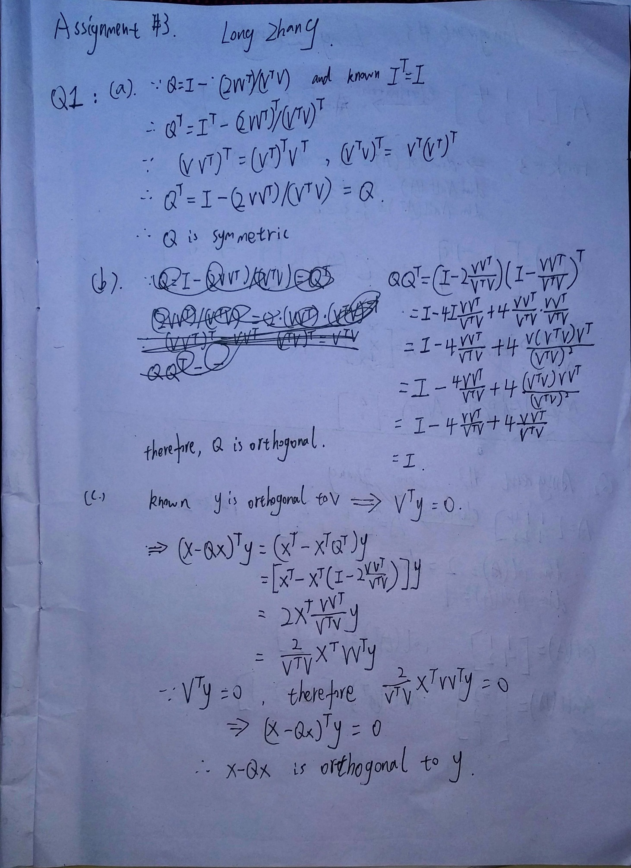

**Q2.**

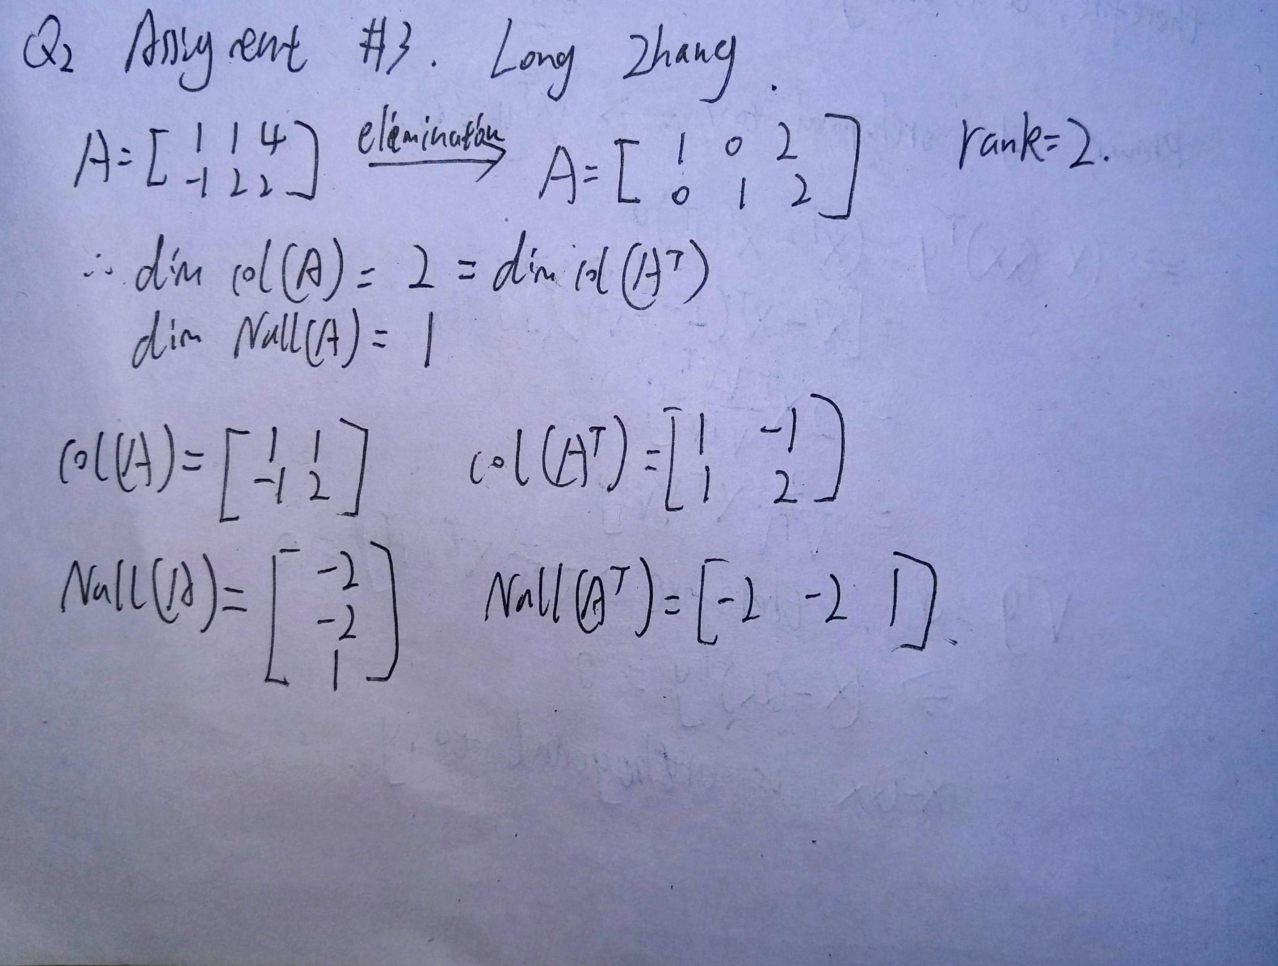

**Q3.A**

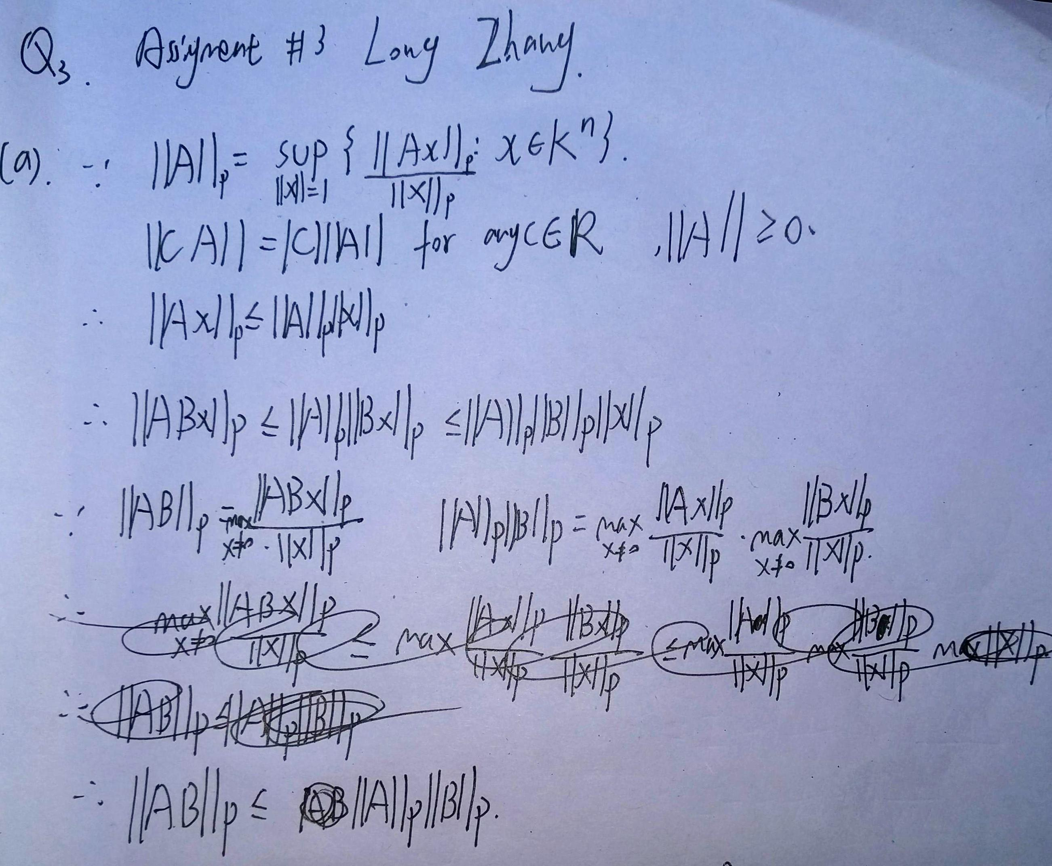

**Q3.B**

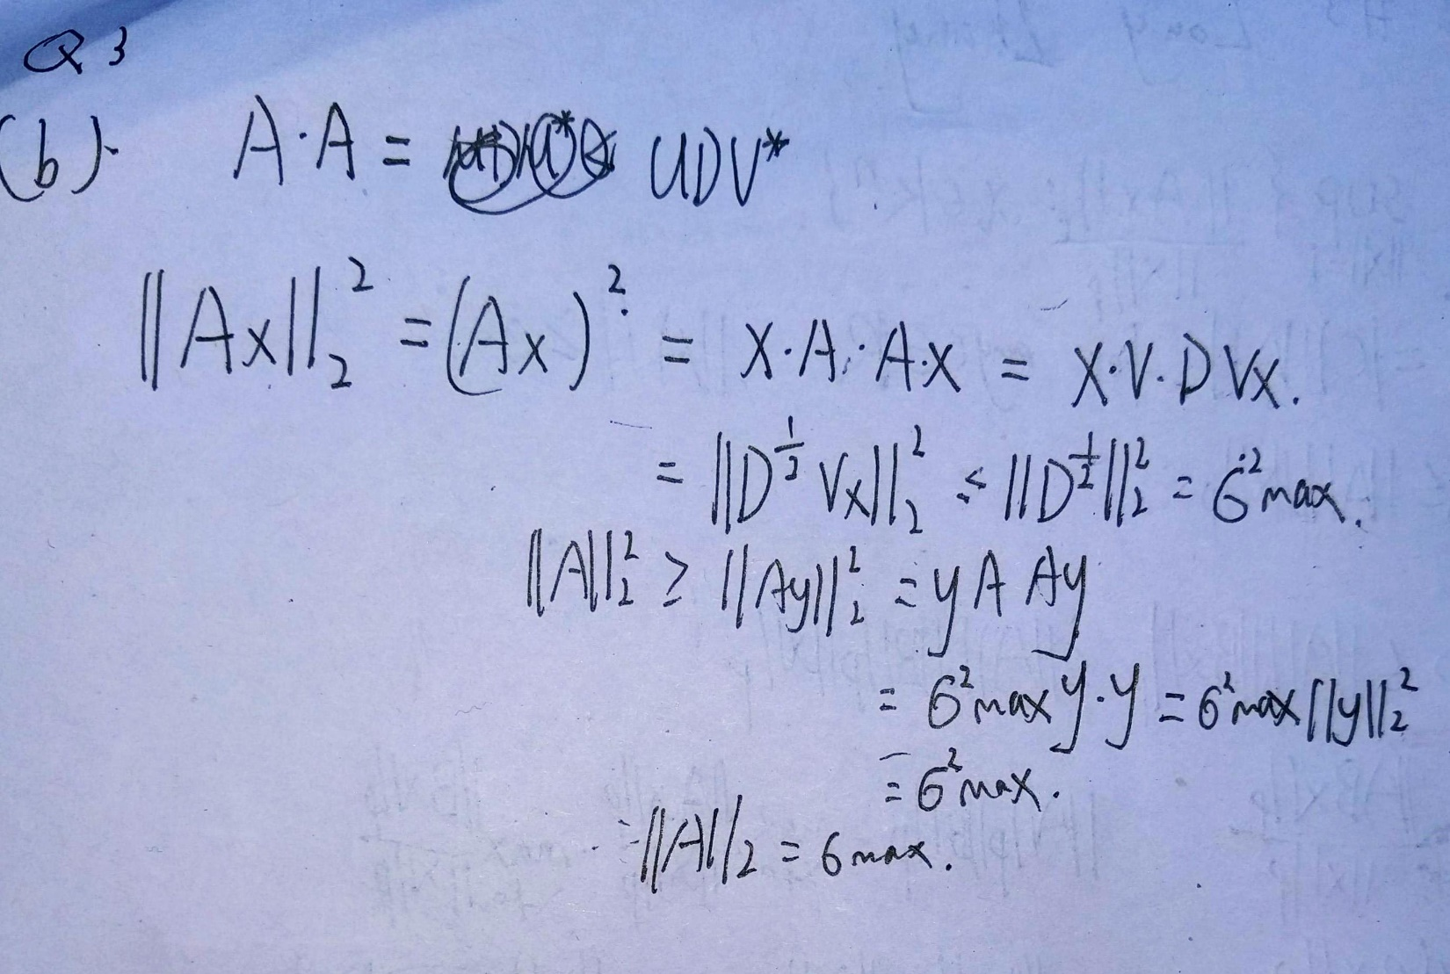

**Q4.**

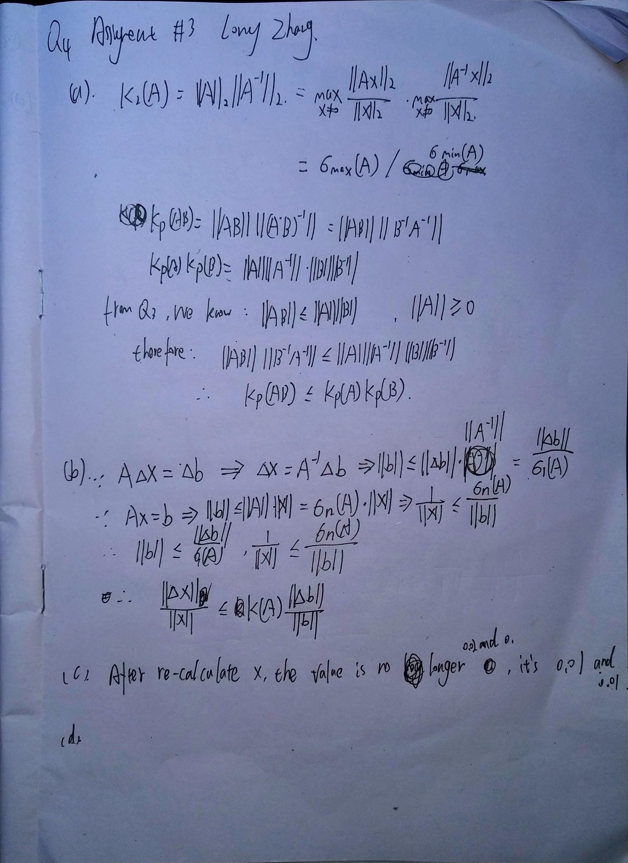

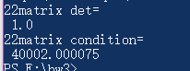

Determinant A : 1

condition number: 40002.000075

**Q5.**

**Result:**

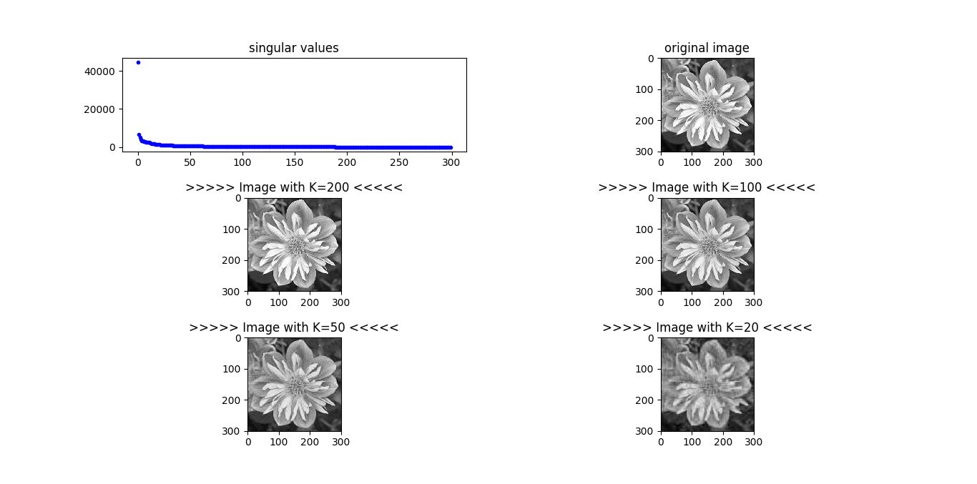

As the K grows from 20 to 200 , the image become more clear, which means the compress rate is getting lower.

* **Is it worth transmitting when K = 200 ?**

Not really, when K = 200, we’re still keeping roughly 160000/300000 pixels. If we keep reduce K, we can get a better compress rate with a good quality.